
MATES Computer Science
Senior Capstone Project Bi-Weekly Progress Report - 3
Project Title | Project Egress
Team Members | Ethan Todd, Liam Bragg, Madeline Rosshirt
Dates Covered by Report | 04/13/26 to 04/15/26 [MIDTERM Dates]; 04/16/26 to 04/17/26; 04/20/26 to 04/24/26; 04/27/26 to 05/01/26
Link to Github | https://github.com/Fennec427/Project-Egress

Summary of Project
Our project is called “Project Egress”. It is a 2-D puzzle platformer made in Unity with pixel art for graphics. Inspired by the video games Splatoon and Portal, the gameplay is centered around the use of different paint colors and their abilities across multiple levels of scaling difficulty. There will also be a variety of tools used to spread the paint. Levels will have stage elements such as spike traps or moving platforms to add a uniqueness to each level.

Summary of Progress this Period
First things we did was fix bugs found and incorporate suggestions from the midterm live demonstration. The bugs fixed were the player bumping up on tiles while moving and being able to jump off solid walls. Both were fixed by combining each tile’s collider into one large collider. The biggest suggestion was to make level 1 easier, which is exactly what we did; removing/replacing some obstacles and also made the level look a bit better visually. Once all those were done, the group split up to work on a “Fire Spitter”, a trap which is similar to the Burner stage obstacle from Super Mario; a paint switching UI, which is done but still needs the rest of painting done to fully implement; and teleporters, which are functional but are needing a small visual change.

Detailed Progress this Period, separated by Team Member

Ethan: To start, I mainly focused on editing Level 1 and working with level creation after I got all of the feedback. I made sure I toned down the difficulty (the most reported criticism) of Level 1 so it matched with the feedback that we got from the sample we let a variety of people try. This itself took a couple of days, but it definitely should help us gauge the process and mindset we need to have when making more levels. After that, we had a couple of pretty major issues (with hitboxes and collisions) that made levels essentially untestable, so I mainly worked on sprites for a few days while Liam got that up and running. We are now in a much better position in that regard. There shouldn’t be a huge amount of spritework that needs to be done now. We everything got set up again, I immediately got back to work on trying to finish Level 1. While Liam was coding a new trap, the “Fire Spitter,” that I sent him, I worked on formatting the end of the Level. This took a little bit, but now it should only really require the new trap, which is nearly done, to be added to finish the shell of what we want with it. Only minor changes, like a way to finish the level as well as some more aesthetics (like a background), should really be needed for it. The aesthetics will mainly be done later down the line and all of the functioning based aspects of the level should be done very soon. With that done, level creation can work more like an assembly with all of the tools in place. My most recent focus I have been working on the past week is a new mechanic to spice up levels past Level 1. This mechanic is a “Teleporter” which works both ways and moves you from one coordinate to another as much as you like. This is also nearly done as well with only minor tweaks needing to be made. I worked on the sprite, code, animations, and any other necessary things only needing a little help from Liam tweaking the code to allow it to fully function. Other than that, I am mainly focused on finishing that up and then moving back to level creation very soon. I will likely work on any other minor aesthetic based things in the background using any small amount of time I get. I also have been keeping a large archive of all of the notes we have had to each other on each day in order to not forget/ lose track of things.
Madeline: After midterms I went to help brainstorm ideas to give to Liam to fix the two new bugs we encountered (which Liam will talk more about). Afterwards I went and made some sprites for paint switching which didn’t go amazingly at first because there was no way to make sure everything was centered except to draw things in manually which took a while. Afterwards I tried to fit my sprites I made previously from the midterm and put them into the wheel but the sprites were too big so I had to restart with an even bigger canvas. It took roughly a day and a half to make but at the time I was still also occasionally talking to Liam about the bugs and a little bit about how paint would work. I also helped Liam navigate the animation editor (Animator) for the first time as up to this point I am the only one who has been working on the animations. After finishing the sprites I made a new branch and started working on making the mechanic work. I started off by simply slowing down the game when the button “e” was held down which worked fine. Afterwards I hit a roadblock as I needed to learn how to make UI elements which took me quite a while to learn what I needed which is why there are barely any commits after Friday. On Wednesday I made it to a point where I actually had stuff to commit but due to lack of time I had to save and power off. On Thursday however with a little bit of help from Liam I was able to get the mouse cursor to change the sprite based off of where the mouse cursor is and more importantly had it pop up over top of the elements of the game. I committed and also merged it into paint for when paint can actually be switched. Either way I need to do most of that again for the 3 way paint wheel which is not going to take as long but will probably still take a day or two based on it being more complex than just a “if the mouse moves left select the left and if the mouse moves right select the right” as there is an option above now (kinda making a triangle). I edited the Trello board during this period too.
Liam: Based on the results of our live interactive demonstration during the Midterm Presentation, I started fixing the bugs that were found, such as the character occasionally bumping up while moving and being able to jump on walls that should not be able to be jumped on. During my attempts at fixing, one of the attempts completely broke the game, making all the ground tiles be affected by gravity. This was because I forgot to set a dropdown to one specific type. Obviously, it was fixed, as we can’t have a working game if it wasn’t. Then I moved to the “Fire Spitter”. This was the first time I had worked with animations, and it seemed to turn out okay, with Maddie’s help. How it works is that there’s idle, warning, and activated states. The idle state has a small amount of fire, but it’s too small to kill the player. The warning state has a larger fire, but it’s still not enough to harm, although the player should be wary, because the spitter is going to activate very soon. In the activated state, there’s now a large fire, which will kill the player. One of the problems with switching states is that the player would not die when they are standing on top of the spitter when it switches from the warning to the activated states. This was fixed with a simple check for the player in an area above the spitter when the state switches, and kills the player if they are found in that area. After finishing, I started helping Maddie with making her paint switching wheel UI and Ethan with his teleporters. Any code I wrote for Maddie was on her computer, as it was easier than having to play this game of commit, push, fetch, pull between us. With Ethan, together we refined his code to teleport the player (async, we both worked on it in our own blocks and communicated our changes in our personal inter-block notes). I also updated the .gitignore file to include some recovery folders/files, as they are meant to be temporary.

Difficulties Encountered this Progress Period
A major difficulty we encountered in this project period involved an attempted bug fix. One issue we noticed from our playtesters was that the collisions between tiles allowed players to bump slightly upwards on floors and jump on the sides of walls (if timed right). When we attempted to fix this issue the first time, the collisions stretched far outside of the block’s sprite (making it impossible to move). The second time we tried to fix this issue, every block was unanchored (including the floor tiles) causing the game to barely run and everything to collapse when the level was started. These issues only took a few days to fix, but it did slow down things for a little (which I guess could be considered the main difficulty for this progress period - things being slowed a little in terms of level creation, although we could still work on other things while that was being fixed (such as sprites)).
As always, the virtual machines being slow was a problem, especially since the guest OS on Liam’s VM would blue screen with the stop code “WHEA_UNCORRECTABLE_ERROR”.

Updated Trello Board and Discussion
https://trello.com/b/D29yQgac/project-egress
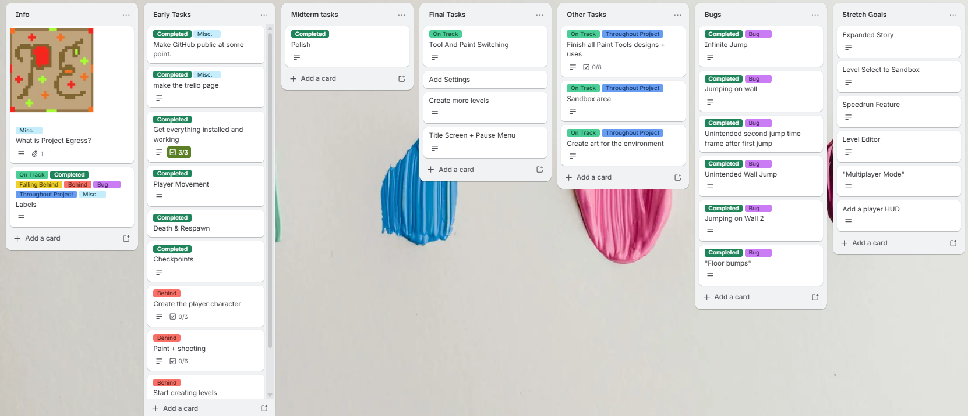
We removed the “Completed” category in order to show better where each task is but renamed the “In Progress” tab to “Other Tasks” which for the most part contains tasks that are being worked on the whole project. Also some of the cards have been edited to have a better description to make them less broad. Also moved the Player Hud to Stretch Goals since while developing it feels like we need the Hud less and less but we will see what happens with it. Other than that not too much to discuss that hasn’t already been mentioned elsewhere. We added two new bugs (which are also completed now). Level Creation and paint are a little behind what we had hoped but things are running smoothly besides that.

Tasks to Be Worked on in Next Progress Period
Paint is definitely a big one that we need to work on as this means our core mechanic is not done. Madeline has been working on the paint switching part which just needs a few more things before being sent over to the painting branch to make code to actually switch the paint type. Level 1 is another big priority but it shouldn’t be too long now as all the obstacles for it are done right now. Other than those things we probably are going to see if we can start working on other ui elements (menus and settings) and some new sprites while paint is getting worked on.

Additional Information
n/a

